**Voice Operated Lift Control System With Safety**

Prof. V. R. Aware1, Bhoknal Gayatri2, Varpe Aditya3, Waman Onkar4, Zanjare Shaileshkumar5

Department of Electronics & Telecommunication Engineering1,2,3,4,5

AMRUTVAHINI COLLEGE OF ENGINEERING, SANGAMNER1,2,3,4,5

**Abstract***: The project introduces a Voice-Operated Lift Control System with a strong emphasis on efficiency and safety. Utilizing an Arduino Mega microcontroller and an array of sensors, including load, flame, and temperature sensors, the system enables voice-controlled elevator operation while prioritizing passenger safety. Sensor faults trigger immediate error responses, including motor halts. Auditory feedback is provided via an audio player module to enhance user experience.*

**Keywords**: Voice-Controlled Elevator, Sensor Integration, Safety Priority, Remote Monitoring.

**I. INTRODUCTION**

**1.1 Overview**

The history of elevators is long and fascinating. The first known elevator was invented by Archimedes in 236 BC. It was a simple hoist powered by human or animal labour. In 1852, Elisha Otis demonstrated the first safety-based elevator. This elevator had a brake that would engage if the cable broke, preventing the elevator from falling. Otis's invention revolutionized the elevator industry and made elevators safe for public use. In 1857, Otis installed the first passenger elevator in a New York City store. This elevator was powered by steam. In 1874,

J.W. Meeker patented a method that allowed elevator doors to open and close safely. This invention made elevators more user-friendly and increased their efficiency. The first residential elevator was created by Clearance Conrad in 1929. This elevator was powered by electricity. In the 1950s, Otis introduced the Autotropic system, which was the first predictive elevator control system. This system could anticipate traffic patterns within a building and deploy elevators in the most efficient manner [1].

Blind people face many problems every day. One of these challenges is the use of elevators in many buildings. visually impaired should be able to enjoy using the elevator easily. Chapter To overcome this challenge for the blind, we must focus on the following issues: Make sure the blind person is at the elevator door Chapter Accept the idea of getting down for the blind person Chapter Attention coming into the elevator from the seat of the blind person [2].

Speech is the superior personality of the human beings gifted by the nature. Speech helps to deliver the thoughts and messages between human. Speech recognition is the process of the computer recognizing human speech to generate a string of words or commands.

Sometimes it is known as automatic speech recognition. Speech recognition is becoming more perplexing and difficult task. The speech recognition research is focuses mainly on large vocabulary, continuous speech capabilities and speaker independence. The design of speech recognition requires cautious attention to some issues like speech representation, depiction of various types of speech Classes, techniques, and database and performance evaluation [3]

.A voice-operated elevator system is proposed where the user’s input commands to control the movement of the elevator system are kept convenient for the users. The commands include voice input for the floor operations, directions, elevator car’s door operation, and a special option to place a call of speaker’s choice in case of any unexpected event that requires immediate action [4].

**1.2 Motivation**

The development of a Voice-Operated Lift Control System represents a significant leap forward in elevator technology, emphasizing both efficiency and safety. This project builds upon a rich history of elevator innovation, from Archimedes' ancient hoist to Elisha Otis's groundbreaking safety mechanisms. By integrating cutting-edge technologies like Arduino microcontrollers, sensor arrays, and cloud connectivity, this system not only enhances user experience but also addresses specific challenges faced by individuals with visual impairments.

Moreover, the project's focus on speech recognition highlights the importance of leveraging natural human capabilities to interact with technology seamlessly. As speech recognition evolves to encompass larger vocabularies and diverse speaking styles, the potential for enhancing accessibility and convenience grows exponentially.

By offering convenient voice commands for floor operations, door control, and emergency assistance, this system empowers users with a more intuitive and user-friendly elevator experience. The motivation behind this project lies in fostering inclusivity, ensuring that everyone, regardless of ability, can navigate built environments with ease and confidence.

**1.3 Problem Definition and Objectives**

The project aims to design a Voice-Operated Lift Control System for efficient elevator control, enhance safety through integrated sensors, provide auditory feedback.

* To develop a system that allows elevator operation through voice commands.
* To implement load, flame, and temperature sensors to monitor elevator safety parameters.
* To create error handling mechanisms that display error messages and stop the elevator motor in case of sensor faults.
* To incorporate an audio player module to audibly announce the selected floor to passengers.

**1.4. Project Scope and Limitations**

The Voice-Operated Lift Control System presents a comprehensive solution for modernizing elevator operations, offering enhanced user interaction, safety monitoring. By integrating voice commands, sensor technology, the project aims to streamline elevator functionality while improving passenger experience and operational efficiency.

**Limitations As follows:**

1. The system's effectiveness may vary based on the quality of speech recognition algorithms and user input clarity.
2. Integration with existing elevator infrastructure may require customization, potentially increasing implementation costs and complexity.

# LITERATURE REVIEW

1. Paper title :- Voice Operated Elevator

Author:- Aishwarya Pokharkar, Niriksha Poojari, Harish Pawar , Amey Patil

Summary :- This project presents the look and construction of voice operated elevator with emergency indicator. This device acts as a human-machine communication system Speech recognition is that the method of recognizing the spoken words to require the mandatory actions in line with the commands. Speech Recognition could be a system that functions to convert auditory communication into the computer file. The system input is human speech. The main purpose of coming up with this method is to control the Elevator by mistreatment voice commands by the user. It aims at serving to unfit, short height folks and physically challenged persons. This projected system is incredibly abundant convenient throughout COVID-19 pandemic.

1. Paper title :- voice Operated Intelligent Lift With Emergency Indicator

Author:- Anu K G, Anupriya K S, Lekshmi M S

Summary :- -This project presents the design and construction of voice operated lift/elevator with emergency indicator. This device acts as human machine communication system. Speech recognition is the process of recognizing the spoken words to take the necessary actions according to the commands. The main purpose of designing this system is to operate the Elevator by using voice commands by the user. It aims at helping paralyzed, short height people and physically challenged persons.

1. Paper title :- Voice Control Elevator for Prevention of Physical Touch

Author:- Archana L. Rane, Archana L. Rane

Summary :- nowadays, usage of the elevator is very common everywhere in out day to day life. The main aim of elevator is to transport the things like person or goods in fraction of seconds. As it has number of advantages so we prefer to use elevator. But as you know, corona virus is spreading all over the world; it is important and mandatory to take precaution by individual and we are sure our propose system help you out in this. The existing elevators can be used by pressing floor number as per needs. These elevators cannot be used by paralyzed, blind and physically challenged persons. In this paper we proposed voice control to elevator to prevent a physical touch as we all as all types of users can be used it easily. We used Arduino Uno ATmega328P microcontroller, Bluetooth module HC-05 and Motor driver unit with Android application. The speech recognition system provides the communication mechanism between the user and the Arduino based elevator control mechanism. We used of a DC motor for moving the elevator based on the voice/speech commands given by the user from mobile application. Its process the data and the result are generated in form of according to the user choices; that is elevator is moves upside or downside.

1. Paper title :- Implementation of Voice based Touchless Lift System

Author:- B. Swathi, Akshay S Prathap, Aiswarya V Kumar, Ranjitha R, Raviteja Kaki

Summary :- In this rapid world of technology where voice begins its era of domination to replace the touch screens from smart phones to huge computer systems, bringing voice in day-to-day affairs becomes significant. An elevator or lift is a transport vehicle that moves people or goods from on floor to another floor in a building. Typically push buttons were used to send requests to the elevators. In recent times touch buttons are coming to use. But now voice recognition can replace the push/touch technology. Elevators being one such system used in daily life serves this purpose of making future generations hands free which also becomes a boon for the disabled as well as helps during the pandemic situation to avoid physical contact. The main objective of this project is to propose and assemble a voice operated lift/elevator control system. The proposed system acts as human machine communication system. This research combines electronic control technology with speech recognition technology. The input to the system is human speech. Speech recognition is the method of recognizing the vocal words to take the essential actions accordingly. This device is very helpful for paralysis, short height people and physically challenged persons.

1. Paper title :- FPGA Implementation of Biometric based Elevator Controller

Author:- Dilip Mathuria, Aditya Gaur

Summary :- In this technical world, with the increasing in the number of skyscrapers, malls, commercial complexes, hotels etc. the need of elevator/lift is essential and it is now become an important part of every skyscraper. It is a device that carries people or luggage to their destined floors inside buildings. Nowadays biometric access is used in elevators to increase security of any lab, hospital, or research centre. This access allows, with only approach the entrance, the device identifies the person by facial, eye or fingerprint recognition and the doors would open. Biometrics is getting great importance in this advanced technical world. Biometrics is a scientific authentication process which depends on attributes of a person. This paper proposes a novel approach to implement a vein fingerprints-based elevator controller using FPGA (Field programmable gate array). Xilinx ISE (Integrated simulation environment) version 14.5 and Verilog HDL (Hardware descriptive language) is used for coding and simulation of the controller.

1. Paper title :- A Study of Speech Recognition

Author:- Kaladharan N

Summary :- Speech is the superior personality of the human beings gifted by the nature. Speech helps to deliver the thoughts and messages between human. Human are trying to develop an intelligent system which can recognize and accept the command via speech, which is known as human computer interface. Speech recognition is the process of the computer recognizing human speech to generate a string of words or commands. Sometimes it is known as automatic speech recognition. Speech recognition is becoming more perplexing and difficult task. The speech recognition research is focuses mainly on large vocabulary, continuous speech capabilities and speaker independence. The design of speech recognition requires cautious attention to some issues like speech representation, depiction of various types of speech Classes, techniques, and database and performance evaluation. This paper presents the review of the different speech recognition system and its recent progress

# REQUIREMENT AND ANALYSIS

1. **DC Motor:** 
   * **Description:** Converts electrical energy (DC) into mechanical energy. Used to control the position of solar panels and wiper.
   * **Application:** Position control.
   * **Quantity:** Three DC motors.
2. **Relay:** 
   * **Description:** Electromechanical switches with high current rating. Used for motor control and isolation.
   * **Types:** Normally Open (NO), Normally Closed (NC), Changeover (CO).
   * **Quantity:** Six relays (two for each motor).
3. **Transistor BC547:** 
   * **Description:** Semiconductor device used for signal amplification or switching.
   * **Application:** Amplification or switching of electronic signals.
4. **Diode (1N4007):** 
   * **Description: Allows current flow in one direction.**
   * **Application: Rectification, converting AC to DC.**
5. **Capacitor:** 
   * **Description:** Stores electrical energy.
   * **Application:** Maintains power supply in electronic devices for a short time.
   * **Types:** 0.1uF, 100uF, 450uF, 470uF.
6. **Resistors:** 
   * **Description:** Implements electrical resistance.
   * **Application:** Reduces current flow, lowers voltage levels.
   * **Types:** 10Ω, 1kΩ, 2.2KΩ, 10KΩ.
7. **Voice Recognition Module:** 
   * **Description:** Recognizes voice commands.
   * **Features:** Speaker-dependent, supports up to 80 voice commands, serial port interface.
   * **Application:** User input recognition, automation.
8. **ISD1820 Audio Player Module:** 
   * **Description:** Records and plays audio messages.
   * **Features:** Non-volatile storage, 10 seconds of recording, playback control buttons.
   * **Application:** Voice playback in projects, message recording.
9. **Flame Sensor:** 
   * **Description:** Detects flames in a specific wavelength range.
   * **Features:** High photo sensitivity, fast response time, adjustable sensitivity.
   * **Application:** Fire detection in firefighting robots, safety systems.
10. **Arduino Mega:**
    * **Microcontroller:** The heart of the Arduino Mega is the ATmega2560 microcontroller, which runs at a clock speed of 16 MHz It has 256 KB of flash memory for program storage, 8 KB of SRAM for data storage, and 4 KB of EEPROM for non-volatile data storage.

**Digital Pins:** The Mega features 54 digital input/output pins, 15 of which can be used for pulse-width modulation (PWM) output.

* + **Analog Inputs:** It has 16 analog inputs for reading analog signals from sensors.
  + **Communication Interfaces:** Supports UART, SPI, and I2C communication protocols.
  + **Operating Voltage:** Operates at 5V.
  + **Power Supply:** Can be powered via USB, external power supply, or battery, with a built-in voltage regulator for stable power supply.
  + **Features and Capabilities:** Ample I/O pins, memory resources, multiple communication options, extensibility via shields, community support, and open-source nature.
  + **Applications:** Home automation, robotics, data acquisition, industrial control, 3D printing, CNC machines, interactive art, among others.

1. **Load Cell:**
   * A straight bar load cell made from aluminium alloy capable of translating up to 5 kg of pressure into an electrical signal.
   * Features four lead wires for connection to an HX711 A/D pressure sensor.
   * Easy to install and operate with a driving voltage of 5-10V.
   * Specifications include dimensions, weighing range, rated output, non-linear output, hysteresis, repeatability, creep, cable length, impedance, temperature effects, operating temperature range, weight, and insulation resistance.
2. **IR Sensor:**
   * Infrared sensor used for various purposes including object detection and motion sensing.
   * Works by emitting and detecting infrared radiation.
   * Two types: active IR sensor (includes both transmitter and receiver) and passive IR sensor (includes detectors only).
   * Components include IR LED and IR photodiode.
   * Circuit diagrams and working principles explained.
   * Pin description includes supply voltage, output voltage, and ground.
3. **Transformer:**
   * 12-0-12 2Amp Centre Tapped Step Down Transformer with 230V primary winding and centre tapped secondary winding.
   * Features solid core and winding with high permeability silicon steel cores.
   * Specifications include input and output voltage, output current, mounting type, winding material, and features.
   * Applications include DIY projects requiring high current drain, on-chassis AC/AC converter, and designing battery chargers.
4. **16x2 LCD:**

A basic LCD display module capable of displaying 16 characters per line with 2 lines.

* + Each character displayed in a 5x7 pixel matrix.
  + Includes command and data registers for controlling the display.
  + Features low power operation support and connector for standard pin headers.
  + Used to display parameters of a solar panel in the project, connected to specific pins of the microcontroller.

# SYSTEM DESIGN

**4.1 System Architecture**

The below figure specified the system architecture of our project.

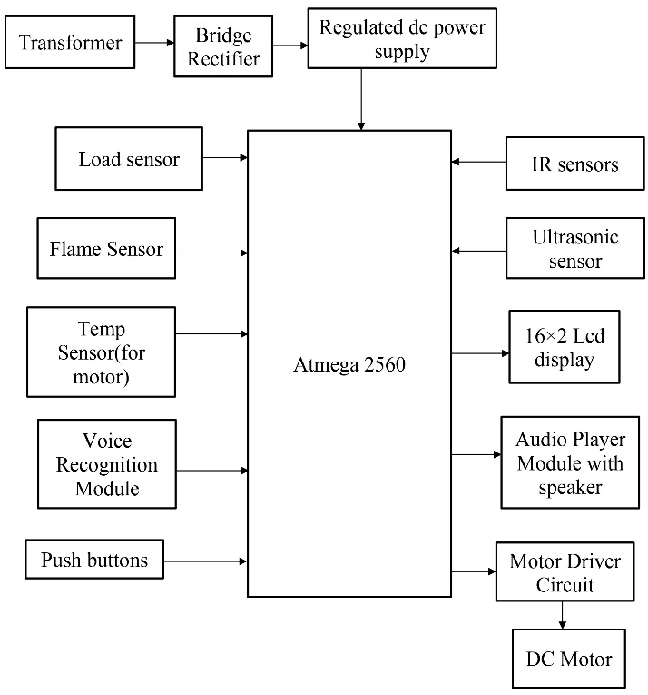

Figure 4.1: System Architecture

**4.2 Working of the Proposed System**

This is description of below block diagram. Here the rectifier is used as a component of power supply. The 230V AC is step down to 12V AC using transformer and is rectified to 12V DC by the rectifier. LM7805 is used as the voltage regulator, which regulates the voltage to 5V [6]. The voice recognition system is the main part of this project. Voice recognition module is communication mechanism between the user and microcontroller. The project will make the use of DC motor for the moving of lift. Microcontroller is programmed, with the help of embedded C programming. The microcontroller can communicate with all input and output modules of elevator.

The microcontroller processes the received voice commands using a voice recognition module. Based on the recognized voice commands, the microcontroller's control logic will determine the appropriate actions to control the elevator, interfacing with the elevator's control circuitry and motor drivers to execute the commands accurately [7]. Load sensors placed within the elevator continuously monitor the weight of the carriage and passengers, ensuring that the elevator does not exceed its maximum weight capacity for safe operation.

The voice recognition module desires to be trained first earlier than it could be used to apprehend instructions. Upon a success recognition of voice command, the microcontroller drives the corresponding load with the assist of the relay circuit [10]. Additionally, the microcontroller incorporates safety mechanisms such as voice-activated emergency stop, weight limit warnings, and vocal confirmation of emergency messages to enhance passenger safety. Overall, this voice-controlled elevator system provides an innovative, user-friendly, and safe elevator experience for passengers while optimizing energy efficiency.

**4.3 Circuit Diagram**

The below figure specified the Circuit Diagram of our project.

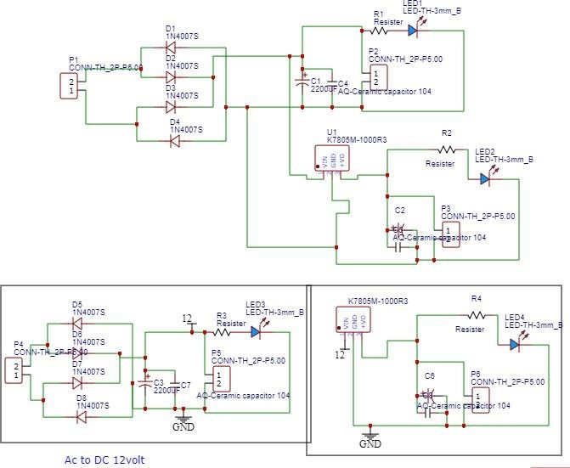

Figure 4.2: Circuit Diagram

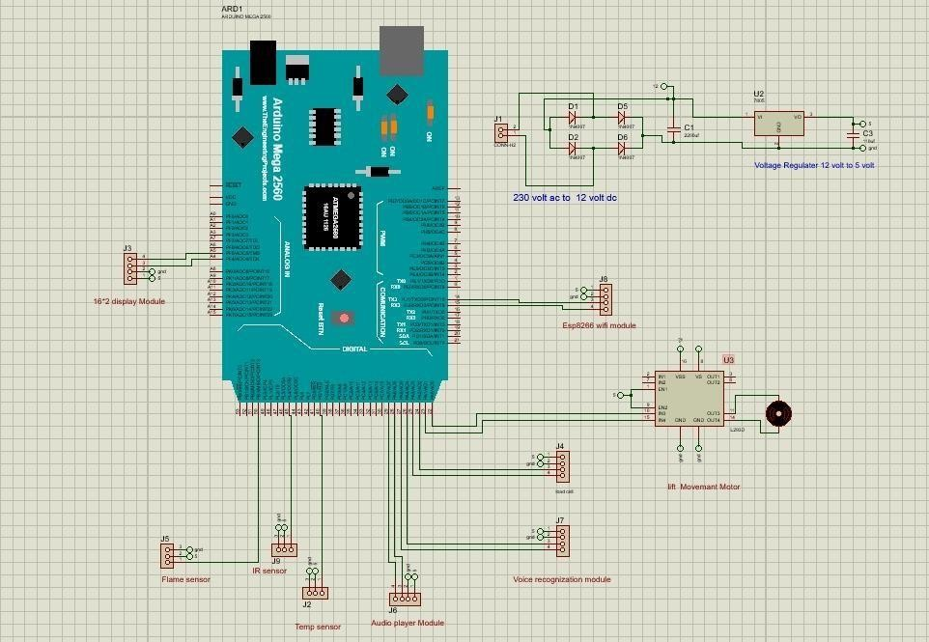

Figure 4.3: Art / Layout

**4.4 Result**

The implementation of the Voice-Operated Lift Control System marks a significant achievement in modern elevator technology, yielding tangible benefits in user convenience, safety, and operational efficiency. Through the integration of voice commands, passengers experience a seamless and intuitive interface, allowing for effortless floor selection and door operation. Moreover, the inclusion of advanced safety features, such as load, flame, and temperature sensors, ensures enhanced passenger protection, with immediate responses to any detected faults to prevent potential hazards. The system's ability to provide auditory feedback further enhances the user experience, offering clear announcements of selected floors and facilitating navigation for individuals with visual impairments. Overall, the successful implementation of the Voice-Operated Lift Control System sets a new standard for elevator functionality, prioritizing user experience, safety, and operational efficiency in today’s-built environments.

# CONCLUSION

**5.1 Conclusion**

In summary, the Voice-Operated Lift Control System combines user-friendly features, safety mechanisms. It offers convenience but may require occasional maintenance and adaptation from users. Its potential applications range from commercial buildings to smart cities, making it a promising advancement in elevator technology.

**5.2 Future Work**

In future iterations, the Voice-Operated Lift Control System could explore enhancements such as natural language processing for more intuitive voice commands, integration of advanced machine learning algorithms to further improve safety prediction and fault detection, and expansion of cloud connectivity features to enable predictive maintenance analytics and integration with smart building systems for seamless interaction with other building automation systems. These advancements would not only enhance user experience and safety but also contribute to the ongoing evolution of smart and connected infrastructure, fostering sustainable and efficient urban environments.

# BIBLIOGRAPHY

1. Lawrence Rabiner and Juang, Biing-Hwang. Fundamentals of Speech Recognition. United State: Prentice-Hall. 1993.
2. Malvino, Albert Paul. Principles of Electronic Volume 2. New York: Salemba Teknika. 2004.
3. M. Fugayama. Objects transfer robot arm control with Shape Similarity Using Kinematics Analysis. Thesis Program S1 Electrical Engineering University of Sam Ratulangi. Manado, 2011
4. . [4] O. Katsuhiko. Automatic Control Engineering (System Settings). Erland, Jakarta,1998.
5. PM Dwisnanto. Design of intelligent Robot Ants Using Microcontroller AVR ATMEGA 16 to determine the shortest track. Thesis S1 Electrical Engineering University of Sam Ratulangi. Manado, 2010.
6. Guangming Xian, Biqing Zeng, Qiaoyun Yun, Xiongwen Pang. Non-Specific Person Continuous Speech Identification in Second Language using BPR. TELKOMNIKA Journal of Electrical Engineering. 2012;10 (7) : 1604-1609.
7. Yutai Wang, Xinghai Yang, Jing Zou. Research of Emotion Recognition Based on Speech and Facial Expression. TELKOMNIKA Journal of Electrical Engineering. Vol.11, No.1, January 2013, pp. 83~90. 2013;11 (1) : 83-90.
8. Jagan.M, Vinitha.N, Ananth.R.Voice Operated Intelligent Elevator. International Journal of Emerging Technology & Research (IJETR). Volume 1, Issue 4, May-June, 2014.
9. Mukesh Kumar, Shimi S.L. Voice Recognition Based Home Automation System for Paralyzed People. International Journal of Advanced Research in Electronics and Communication Engineering (IJARECE). Volume 4, Issue 10, October 2015.
10. Pande Divyaprasad Digambarrao, M. Praveen Kumar. A Smart Device for People with Disabilities using ARM7.

International Journal of Engineering Research & Technology (IJERT). Vol. 3 Issue12, December2014.

1. Prabhakar V. Mhadse, Amol C Wani Speaker Identification Based Automation System through Speech Recognition.

International Journal of Emerging Technology and Advanced Engineering (IJETAE). Volume 3, Issue 1, January 2013)